PETROF is now with you for over 155 years
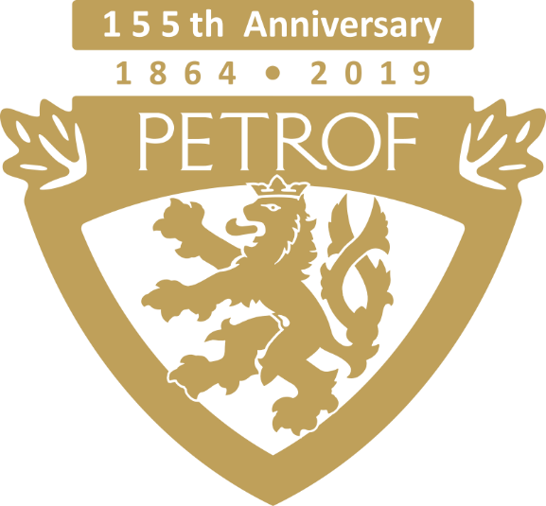

The company PETROF, spol. s r.o. has become over the course of its existence the largest producer of pianos and grand pianos in Europe. It has been 155 years since Antonín Petrof built his first piano and thus the company PETROF celebrates its 155th anniversary this year. PETROF continues to pride itself on quality handwork, careful selection of raw materials and an unmistakeable romantic sound, which inseparably belongs to PETROF instruments. To mark and celebrate this year’s anniversary, the company PETROF created 3 new special instruments and proudly continues in its honest craft and family tradition.
The first one of PETROF’s anniversary instruments is the Tiger Wood piano. This instrument featuring the characteristic tiger wood veneer is designed for lovers of a pure and modern design. This hard wood, valued for its beautiful motif and structure, resembles flames of a fire.

The second piano of the PETROF’s anniversary instruments, that were created to mark the company’s 155th anniversary, is Walnut Root. Walnut tree, a traditional tree in our latitudes, draws its strength from its deep roots, thanks to which it can live for centuries. In a similar fashion, we went back to our roots and to the mindset of our ancestors, who widely used the walnut wood. Only one look at the beautiful motif of this veneer has the power to take you back to their time. Playing this instrument is a great way to honor the memory of our ancestors.

The piano Stingray, the only piano of its kind, built for the special occasion of the 155th anniversary of the company PETROF, concludes the list of PETROF’s anniversary instruments. The most significant and unique feature of the piano is the decoration of its extraordinarily shaped legs, which are inlayed with pieces of a stingray skin. The skin of a stingray will mesmerize all your senses. It is incredibly tough and durable, yet it is surprisingly soft to a touch. Its appearance resembles small beads that look like the nature itself put them together. Every stingray has a typical dorsal fin in the shape of a diamond - similarly unique are also fingerprints of the master craftsman, who was responsible for the creation of this instrument.

The public can look forward to an Open Day, which will take place on September 7, 2019. Visitors will have the opportunity to experience the unique atmosphere of the workspaces of the factory, where they can see with their own eyes how our skilled employees build instruments that bring happiness to thousands of satisfied customers around the world. Part of the tour around the factory will be a visit to the PETROF Museum, where some of the most interesting exhibits from the company’s history are located. The tour will conclude in the building of the new cultural center PETROF Gallery, which was awarded the title Building of the Year of the Hradec Králové Region.
For more information please visit www.petrof.cz
Contact person:
Bc. Gabriela Mikulecká
mikulecka@petrof.com
PETROF, spol. s r.o., Na Brně 1955, 500 06 Hradec Králové
www.petrof.cz

